# Guide – I2D2 Folder Structure

Under I2D2 the folders and the surveys were stored differently to the structure proposed by the Microdata Library.

Within a country, the first level is the year when a survey took place (or when it started if it takes place over more than a year) (see Figure 1).

Figure 1 - I2D2 Folder Structure

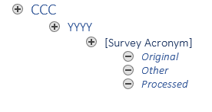

Within a year there you find the survey, identified by its acronym (for example LFS for a labour force survey, or HIES for a Household Income and Expenditure Survey). There can be several surveys in a single year.

Within a survey there are three folders: *Original* contains the original files. Sometimes you may find other ancillary information here (e.g., questionnaires or other blocks of the survey not used like a WASH module). *Other* should contain all other information, that is the questionnaires as well as intermediate output produced while creating the harmonization. Finally, *Processed* contains the do file used to create the harmonization as well as the .dta output it created. Often there will also a Excel file. Historically, I2D2 was harmonized using an Excel template.